Vehicle Insurance System
Software Requirements Document
V 1.0


 | Prepared By | Reviewed by | Approved By
Name | Rajeshwar Chary
Role | Team member | Project Leader/ Team Leader/ Team Member | Project Manager/ Team Leader
Signature | VS
Date | 11/14/2014

Table of Contents
1.0 Introduction 3
1.1 About this document 3
1.1.1 Purpose & Scope of the document 3
1.1.2 Intended Audience 3
1.2 About the Software System 3
1.2.1 Purpose 3
1.2.2 Scope of the system 3
1.2.3 Exclusions 4
1.2.4 System Perspective 4
1.2.5 System diagram 5
1.2.6 System Environment 5
1.2.7 User Characteristics 6
1.2.8 Impact of the System 6
1.2.9 Assumptions, Dependencies, Risks / Constraints 6
1.2.10 Design Constraints 6
2.0 System Requirements 7
2.1 System use-cases 7
2.2 Supplementary requirement specification 8
2.3 Non functional Requirements 8
2.3.1 UI Requirements: Inn 8
2.3.2 Performance Requirements: Pnn 9
2.3.3 Installation, Deployment & Operational Requirements: Onn 9
2.3.4 Maintainability & Portability Requirements: MPnn 10
2.3.5 Security Requirements Snn: 10
3.0 Requirements / Use Case Summary Table 10
4.0 Make /Buy analysis 12
4.1 Reusable components 12
5.0 Annexure 12
6.0 Change Log 12

Introduction

About this document

Purpose & Scope of the document
The purpose of the software requirements document is to systematically capture requirements for the project and the system “Vehicle Insurance System” to be developed. Both functional and non-functional requirements of this system are captured in this document. It also serves as the input for the project scoping
The scope of this document is limited to addressing the requirements from a user, quality, and non-functional perspective. It is recommended that design aspects are not added in this document

Intended Audience
Project Team

About the Software System
The following section will cover aspects related to
Vehicle Insurance System will allow end user to manage policies with ease.

Purpose
Vehicle Insurance System (VIS) is basically a system that helps to members to do vehicle insurance online, by registering the vehicle, pay premium, and renew policy and cancelling policy. The following are the modules in this proposed system
- Customer Registration
- Vehicle Registration
- Pay Premium
- Claim Policy
- Cancel policy

Scope of the system
The scope of the system is explained through its modules as follows

  - Customer Registration – Customer should register with his details into the system before he logs in to the application.
  - Vehicle Registration – Administrator needs to register the details of a vehicle into the system
  - Pay Premium - Users to pay the premium for their own vehicle
  - Claim Policy- Users to claim the policy amount for their own vehicle
  - Cancel/Revoke Policy - Administrators to cancel the policy details of the user from the system

Exclusions
- The system will operate only on the modules discussed above and will not include any additional functionality.

Use Case Diagram
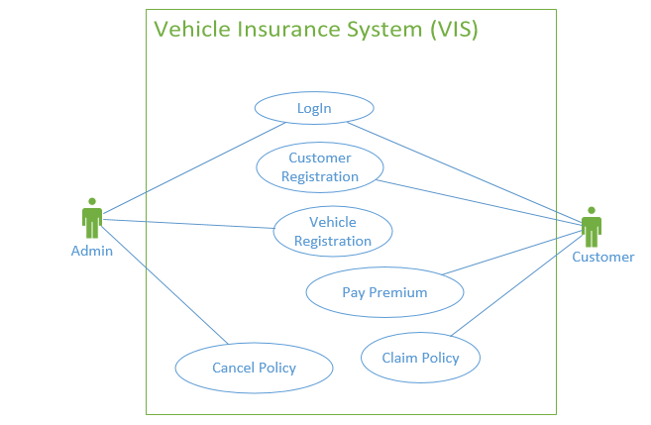

System Perspective
The VIS is an independent software system developed to manage the activities like Customer Registration ,Vehicle registration, Pay Premium, Claiming Policy, Cancel policy using the Java/Dotnet architecture.

System diagram
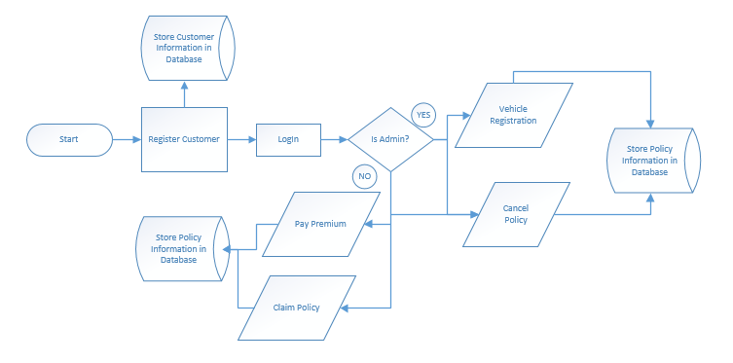

Architecture diagram

Physical Architecture:
A physical architecture is an arrangement of physical elements, (system elements and physical interfaces) that provides the designed solution for a product, service, or enterprise. It is intended to satisfy logical architecture elements and system requirements. Vehicle Insurance Process follows a three layered architecture namely presentation layer, business logic layer and data access layer.
- Presentation Tier is the tier in which the users interact with an application. Presentation Tier contents Shared UI code, Code Behind and Designers used to represent information to user.
- Business Tier is mainly working as the bridge between Data Tier and Presentation Tier. All the Data passes through the Business Tier before passing to the presentation Tier. Business Tier is the sum of Business Logic Layer, Data Access Layer and Value Object and other components used to add business logic.
- Data Tier is basically the server which stores all the application’s data. Data tier contents Database Tables, XML Files and other means of storing Application Data.
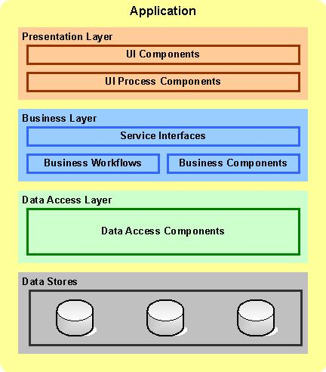

Logical Architecture:
The Logical Architecture defines the Processes (the activities and functions) that are required to provide the required User Services. Many different Processes must work together and share information to provide a User Service. The Processes can be implemented via software, hardware, or firmware. The Logical Architecture is independent of technologies and implementations.

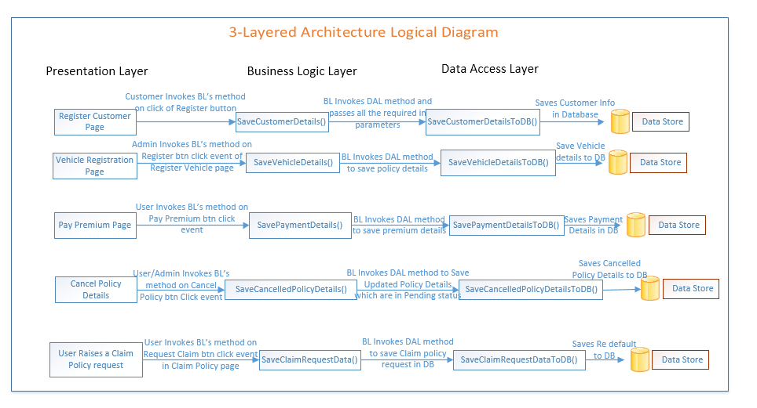

System Environment
The VIS application will be operated from the client server with parallel processor support. When a user connects to the Web Server, the Web Server will interact with the Database after processing the business logic to transfer data to and from a database.
- Java/J2EE or .NET Framework application deployment.
- My SQL/SQL server database for data storage

User Characteristics
The application should be user friendly; in such a way that the user would not need any software and hardware knowledge. The user may be new to the client products having never used them before.
The types of users likely to use the system are as follows,
- Client
- Delivery Assurance Group, Process Engineering group
- Developers, testers, other associates in the project

Impact of the System
This is a new product which is developed for internal users. Expected impact of the product is to automate existing manual processes in order to make them more efficient and cost effective.

Assumptions, Dependencies, Risks / Constraints
Assumptions:
- The processing admin must possess prior knowledge on VIS operations undertaken offline.
- The admin should have the details of the policies and vehicles to be registered /updated into the system.
Dependencies:
- If there is any vehicle Insurance payment procedure is required for other applications of the same client, this system should be able to accommodate such a reusability dependency.
Risks:
- If there is any failure in vehicle Insurance policy payment processes, the system should be able to handle such a financial risk.

Design Constraints
- The Vehicle modules and the Policy modules should remain independent, without affecting the policy payment operations.
- Application should have single login feature. Login functionality should be the welcome feature for the application.
- Only administrator can access the application.
- None of the application features can be accessed without login.

System Requirements

Functional Requirements

Home Module
Vehicle Insurance System  Req-2.1.1 | Home Page
Functional Requirements
When the users enter the following link http://localhost:8080/VehicleInsuranceSystem in the browser, Home page appears which will have a short welcome message; a brief introduction to the purpose of the Vehicle Insurance Process, the user can choose appropriate options.
Under home page, we need below interface.
Home page Interface Requirements
- Admin
- User
- About Us
- Contact Us

Customer Register Page
Vehicle Insurance System  Req-2.1.2 | Customer - Registration
Functional Requirements
When the User/Customer clicks on the registration link, it should re-direct to registration form and the Vehicle Insurance System user need to fill some of the basic attributes/fields as mentioned below in requirement

User Name ,Password, First Name, Last Name, Age, Gender (Male or Female) ,Contact Number
E-mail, Address, pin code, City.

At any given point of time, the user can Deselect/Reset all or can go to home page by the clicking home.
User Interface Requirements
- Name - Name of the Customer.
- Password – Represents the customer password.
- Address – Represents the Customer’s Address.
- City – Represents the Customer’s City.
- State – Represents the Customer’s State.
- Country – Represents the Customer’s Country.
- Pin Code – Represents the customer’s Pin Code.
- Email Address – Represents the customer’s Email Address.
- Gender – Represents the customer’s Gender.
- Contact No – Represents the customer’s Contact Number.
- Date of Birth – Represents the customer’s Date of Birth.
- Customer ID – Represents the Generated Customer ID.
- There should be 2 buttons i.e. Register, reset
Trigger
- Customer should register into the system before he logs in to the application
Post Conditions
- The system should generate the customer id and store along with the customer details.
Success End Condition
- On success a message should be displayed “Customer Registered successfully”

Failed End Condition
- The system should throw an error message if one of the validations is wrong. The error message and error code needs to be identified during design.
- The validation and business rules are mentioned in the business rules section.

Steps & Actions
- System should display all the necessary details.
- Get all the necessary information.
- Generate the customer ID as follows.
Customer ID= current year (4 digit) +current month (2 digit) +unique number (4 digit).
Example: 2012055001.
- Store the details into the system
Business Rules & Validations
- The name should contain only alphabets and space.
- Password should contain at least one lowercase, one uppercase and one digit.
- Pin code should be 6 digits.
- Contact no should be 10 digits.
- Email id should be in a valid format (abc@xyz.com).
- Age should not be above 90 years.
- All details are mandatory.
- Address should not contain special characters other than white space. Blank not allowed
- At the time of registration, the following task needs to be done:
- Update the above details automatically into the database along with the customer details.

Vehicle Registration Module

Vehicle Registration Page
Vehicle Insurance System  Req-2.1.3.1 | Vehicle Registration Page
Functional Requirements
This will be used by administrators to register the details of a vehicle into the system. The administrator should have the details of the vehicle to be entered into the system. The system should calculate the premium amount and discount amount for each vehicle type and store the details in the system.
User Interface Requirements
- Vehicle registered in the name of- Name of the vehicle owner as registered.
- Vehicle Registration state- State of vehicle registered
- Vehicle type- Select the type of vehicle
- Manufacturer- Selects the vehicle manufacturer
- Model- Selects the model type based on manufacturer
- Engine number- Represents the vehicle engine number
- Year of make- Represents the vehicle make year.
- Registering location- Represents the location of the vehicle to be insured
- Price- Represents the vehicle price
- DOP- Represents the Date Of Purchase of vehicle
- Register- Submit Button used to register the vehicle details into the DB.

Trigger
- Administrator triggers the functionality once he/she receives the details of the policy.
Pre-Conditions / Assumptions
- The admin should have the details of the vehicle to be registered into the system.

Post Conditions
- The premium, discount amount and maturity date of the vehicle insurance will be calculated and stored along with the vehicle details.

Success End Condition
- On success a message should be displayed “Vehicle Registered successfully” and in same page details should be shown “Policy No, Premium Amount, and Maturity Date”
Failed End Condition
- The system should throw an error message if one of the validations fails. The error message and error code needs to be identified during design.
- The validation and business rules are mentioned in the business rules section.
Steps & Actions
- System should display all the necessary fields in the screen.
- Policy id should be generated automatically during the time of registration.
- Policy id should start with vehicle type, last two digits of year and followed by 4 digit number.
Example: For two wheeler
TW140001
For four wheeler
FW140001
- The vehicle type should be fixed(two wheeler/four wheeler/others)
- The vehicle model should be loaded automatically based on the selection of manufacturer

For two wheeler

MANUFACTURER | MODEL
HONDA | Splendar
HONDA | Splendar plus
HONDA | Passion Plus
HONDA | Activa
TVS | Victor GLX
TVS | Sport
TVS | Apache
TVS | XL Super
TVS | Heavy Duty
TVS | Scooty pep
MAHINDRA | Duro
BAJAJ | Pulsar
BAJAJ | Discover
BAJAJ | Boxer

For Four wheeler

MANUFACTURER | MODEL
HONDA | Accord
HONDA | City
HONDA | Amaze
TOYOTA | Etios
HYUNDAI | Venture
HYUNDAI | Accent
MAHINDRA | Scorpio
MAHINDRA | XUV
CHEVROLET | TAVERA
CHEVROLET | Spark
SKODA | Fabia
VOLKS WAGEN | Punto

- The vehicle registration state should belong to India (state should be selected from drop down)
- The registering location and the vehicle registered state should be same.
- If the vehicle class is own vehicle allow normal premium calculation.
- If the vehicle class is used for public facilities allow advance premium calculation.
For Own vehicle,
Premium Amount=price of vehicle * 6.5%
For others,
Premium Amount=price of vehicle * 6.5%+(tax)
Tax=3.4% of price of vehicle

- The insurance amount should be half of the vehicle price if the model of the vehicle is before 5 years from the current year.
- The maximum insurance amount for any vehicle is 2% greater than the price of vehicle
- If the vehicle is getting registered within one month of purchase 3% discount will be offered in premium
- On clicking register, system should calculate the premium based on the Insurance amount and discount.
- The premium date calculated based on the following
Premium Date = Registration date+ one year
Business Rules & Validations
- All fields are mandatory.
- The name should contain only alphabets and space.
- The vehicle registration state should belong to India
- The Engine Number should not have space and special characters
- The year of make should be Numeric
- The registering location should belong to India

- The price field should be numeric
- Date of purchase should be less than the current date
- The policy id should be automatically generated by the system.
- During the registration following tasks needs to be done:
  - Discount will be calculated based on the vehicle registration date.
  - Premium Amount will be calculated.
  - Maturity Date will be calculated.

Pay Premium Module

Pay Premium Page
Vehicle Insurance System Req-2.1.4.1 | Pay Premium Page
Functional Requirements
This Module will be used by users to pay the premium for their own vehicle. The user should have the insurance details to be entered into the system. The system should allow the user to pay premium in two modes like direct pay and registered pay. The system should identify the payment information so that the due amount and the late payment charge can be calculated. The system should maintain the history of payment options.
User Interface Requirements
Payment Types:
- Direct pay- Link to load the Direct pay mode page
- Registered pay- Link to load the Registered pay page
Direct pay premium

- Policy Id- The policy id of the vehicle insurance
- Amount- The premium amount to be paid
- Mode of Payment- The user’s payment mode
- Debit card- The debit card option to pay premium
- Credit card- The credit card option to pay premium
- Contact no- Represents the contact no of the user
- Net banking- The Netbanking option to pay premium
- Pay- Submit button to pay premium
- Reset- Clear fields
Registered pay
- Policy Id- The policy id of the vehicle insurance
- Password- The password of the user
- Login- The submit button to login
- State- The Registered state of the user
- Vehicle type- The vehicle type of the user
- Model- The model of the vehicle
- Payment mode- The label to display the choice of payment
- Debit card- The debit card option to pay premium
- Credit card- The credit card option to pay premium
- Contact no- Represents the contact no of the user
- Net banking- The Netbanking option to pay premium
- Pay- Submit button to pay premium
- Reset- Clear fields

Trigger
- Administrator triggers the functionality once he/she receives the details of the policy.
Pre-Conditions
- The user should have the insurance details of the vehicle for which the premium has to be paid
Post Conditions
- The payment id and next due date has to be calculated and stored along with the payment details.
Success End Condition
- On success a message should be displayed “Payment processed successfully” and in same page details should be shown “Payment id and the next payment Date”
Failed End Condition
- The system should throw an error message if one of the validations fails. The error message and error code needs to be identified during design.
- The validation and business rules are mentioned in the business rules section.

Steps & Actions
- System should display all the necessary fields in the screen.
- System should give two modes of payment
  - Direct pay
  - Registered user payment
- Direct Pay Mode
  - Policy id should be existing
  - User can directly enter the premium amount
  - If the payment date is over due date the user can’t make Direct payment.
  - The user can make 3 modes of payment like debit card, credit card and net banking
  - If the user is making payment through credit card add service tax of 2.3% of premium amount.
  - The payment id should be generated automatically at the time of payment.
  - The payment id should start with first three letters of month followed 3 digits
- Registered Pay mode
  - The user should log in to the system using the policy id and password
  - The system should display the vehicle information like registered state, type of vehicle, and the model along with the policy id
  - If the payment date is over due date calculate the late payment charges as per the following criteria
    - Add 0.56% of premium amount per day
  - The user can make 3 modes of payment like debit card, credit card and net banking
  - If the user is making payment through credit card add service tax of 2.3% of premium amount.
  - The payment id should be generated automatically at the time of payment.
  - The payment id should start with first three letters of month followed 3 digits.
    - Example : APR0001
- Find the policy information as mentioned below

POLICY ID | Vehicle Owner | Vehicle Registration State | Vehicle Type | Vehicle Class | Manufacturer | Model | Engine Number
TW14001 | Peter | Tamilnadu | TW | OWN | Honda | Passion Plus | 4871236
FW14002 | John | Andhra | FW | OWN | Toyota | Etios | 7811581

Contd…
Make Year | Registering location | Date of Purchase | Price | Premium amount
2004 | Tamilnadu | 12-05-2008 | 50000
2012 | Andhra | 08-06-2014 | 500000

Business Rules & Validations
- All fields are mandatory.
- The Policy Id should be existing
- Price should not consist of characters
- The vehicle registered date should not be greater than the current date
- The price field should be numeric
- The payment id should be automatically generated by the system.
- During the registration following tasks needs to be done:
  - Payment ID should be calculated
  - Next date the premium amount to be paid

Claim Policy Module

Claim Policy Page
Vehicle Insurance System Req-2.1.5.1 | Claim Policy Page
Functional Requirements
This Module will be used by users to claim the policy amount for their own vehicle. The user can claim the policy amount for the perfect reasons like accident and theft. The user should have details to claim the policy amount. For accident claim the user should submit the proof of damage. For theft claim the user has to submit FIR details filed in police station. The user is eligible to claim the amount based on weightage. The claimed policy details should be stored in the system.
User Interface Requirements
Claim Policy Selection Screen
- Policy Id- The policy id of the vehicle insurance
- Accidental Claim- Submit button to load the accident claim screen
- Theft claim- Submit button to load the theft claim screen
Accident Claim Screen
- Username- The vehicle owner name
- Total amount- The total premium amount
- Accident type- The type of accident
- Weightage- The weightage calculated
- Claim- Submit button to claim premium
- Reset- Clear fields
Theft claim Screen
- Username- The vehicle owner name
- Total amount- The total premium amount
- Date of theft- The date in which the vehicle is missing
- Date of compliant- The date in which the complaint is registered
- FIR number- The FIR number in which the complaint is registered
- Police station Branch- The branch where the complaint is registered
- Claim- Submit button to claim premium
- Reset- Clear fields

Trigger
- Administrator triggers the functionality once he/she receives the claim details.
Pre-Conditions
- The user should have the claim details of the vehicle for which the premium has to be paid
Post Conditions
- The claimed policy details and the history of payment has to be stored in the system along with the claim id.
Success End Condition
- On success a message should be displayed “Claimed processed successfully” and in same page details should be shown “Claim id and the claimed amount”
Failed End Condition
- The system should throw an error message if one of the validations fails. The error message and error code needs to be identified during design.
- The validation and business rules are mentioned in the business rules section.

Steps & Actions
- System should display all the necessary fields in the screen.
- System should give two modes of claim
  - Accident
  - Theft
- Accident Claim
  - Policy id should be existing
  - Based on the policy id the user name and the total premium amount paid by the user should be populated from the system
  - Based on the reason of accident weightage will be calculated
ACCIDENT TYPE | WEIGHTAGE
Fire | W1
Road accident | W2
Malicious Acts | W3
Self-destruction | W4
Part Failure | W5

  - The user is eligible to claim amount based on the weightage calculated as per damage as follows
For two wheeler

WEIGHTAGE | COST in Percentage of vehicle price
W1 | 80
W2 | 70
W3 | 50
W4 | 40
W5 | 20

  - The damage cost below 5000 is not eligible to claim
For four wheeler
WEIGHTAGE | COST in Percentage of vehicle price
W1 | 70
W2 | 65
W3 | 50
W4 | 30
W5 | 20

  - The damage cost for two wheeler below 5000 is not eligible for claim.
  - The damage cost for four wheeler below 20000 is not eligible for claim.
  - Based on the type of accident the weightage should be populated
  - On clicking submit the claim id should be generated along with the claim amount
  - Theft Claim
  - Policy id should be existing
  - Based on the policy id the user name, vehicle manufacturer, model, engine number and the total premium amount paid by the user should be populated from the system
  - The FIR details of the complaint registration should be stored in to the system
  - The FIR number, police station branch, the date of theft and the compliant date should be inserted to the system
  - On clicking submit the 75% of the amount should be allocated as claim amount
  - If the vehicle is claimed insurance already for accident it is not eligible for reclaim. The policy should be closed
  - On clicking submit the claim id should be generated along with the claim amount
  - The claim id should start with first three letters of month followed by last 2 digits of year and followed 3 digits.
    - Example : APR140001
- Find the policy information as mentioned below

POLICY ID | Vehicle Owner | Vehicle Registration State | Vehicle Type | Vehicle Class | Manufacturer | Model | Engine Number
TW14001 | Peter | Tamilnadu | TW | OWN | Honda | Passion Plus | 4871236
FW14002 | John | Andhra | FW | OWN | Toyota | Etios | 7811581

Contd…

Make Year | Registering location | Date of Purchase | Price
2004 | Tamilnadu | 12-05-2008 | 50000
2012 | Andhra | 08-06-2014 | 500000
- The payment information as follows
POLICY ID | PREMIUM AMOUNT | DUE DATE | PAYMENT DATE | PAYMENT MODE | AMOUNT PAID | PAYMENT ID
TW14001 | 350 | 12-05-2008 | 11-05-2008 | Debit card | 350 | MAY0001

Business Rules & Validations
- All fields are mandatory.
- The Policy Id should be existing
- The FIR number can be maximum of 10 digits
- The police station should belong to the state where the vehicle is registered
- The date of theft should be maximum of 10 days of date of compliant registration
- If the user is already claimed any insurance for any reason is not eligible for reclaim
- The claim id should be automatically generated by the system.
- During the registration following tasks needs to be done:
  - Claim ID should be generated
  - The claimed amount should be calculated and displayed

Cancel Policy Module

Cancel Policy Page
Vehicle Insurance System Req-2.1.6.1 | Cancel Policy Page
Functional Requirements
This Module will be used by administrators to Cancel the policy details of the user from the system. There are two ways a policy can be cancelled.
1) If the user has not paid the premium amount from the last 3 months the administrator will cancel the insurance policy and close the account of the user. The user has to raise request for new insurance policy or the user can withdraw the paid amount with penalty based on weightage.
2) The user can raise a request for cancelling the insurance policy for any reason. If the user wants to cancel the policy within 3 month of insurance registered date the user is not eligible withdraw the amount paid. If the user is cancelling after 3 months he/she is eligible to cancel the policy with a penalty of 12.5% of the total amount paid.
Once the system is submitted with the policy id it should display the insurance details like owner name, registration date, vehicle type, manufacturer, Engine Number, registration date of the vehicle. The updated information has to be stored in to the system with the cancel id.

User Interface Requirements
Policy Id – Represents the policy Id
Cancellation Date - Represents the date on which policy has been cancelled
Submit button – On click of Submit button policy details are displayed
Cancel button - On click of Cancel button policy should be cancelled

Trigger
- Administrator triggers the functionality once he/she receives the details of the policy.
Pre-Conditions
- The admin should have the details of the policy to be cancelled from the system.

Post Conditions
- If the policy is cancelled then the details will be deleted and stored as a backup in the system.

Success End Condition
- On success a message should be displayed “Policy Cancelled successfully with cancel id”
Failed End Condition
- The system should throw an error message if one of the validations fails. The error message and error code needs to be identified during design.
- The validation and business rules are mentioned in the business rules section.

Steps & Actions
- System should display all the necessary fields in the screen.
- The system should accept the policy id and select the way of cancellation
- Admin cancellation
  - Entering the policy id and after clicking the submit the system should display the details of policy like owner name, registration date, vehicle type, manufacturer, Engine Number, registration date of the vehicle.
  - Find the insurance details as follows
POLICY ID | Vehicle Owner | Vehicle Registration State | Vehicle Type | Vehicle Class | Manufacturer | Model | Engine Number
TW14001 | Peter | Tamilnadu | TW | OWN | Honda | Passion Plus | 4871236
FW14002 | John | Andhra | FW | OWN | Toyota | Etios | 7811581
Contd…
Make Year | Registering location | Date of Purchase | Price
2004 | Tamilnadu | 12-05-2008 | 50000
2012 | Andhra | 08-06-2014 | 500000

  - After click of cancel the system should display the details like total amount paid by the user, date of last premium paid.
The payment information as follows
POLICY ID | PREMIUM AMOUNT | DUE DATE | PAYMENT DATE | PAYMENT MODE | AMOUNT PAID | PAYMENT ID
TW14001 | 350 | 12-05-2008 | 11-05-2008 | Debit card | 350 | MAY0001

  - The admin will enter the current date and calculates the weightage for penalty amount as follows
WEIGHTAGE | NO OF MONTHS | PERCENTAGE OF TOTAL_AMOUNT
W1 | 2 | 7
W2 | 4 | 10.25
W3 | 6 | 12.35
W4 | >6 | No repayment
  - The number of months exceeding 6 is not eligible for withdraw of amount
  - The system should automatically check the month difference and the weightage will be populated from the database
  - After click of submit the system should generate the cancel id based on the cancel date followed by 3 digits as follows
    - Cancel Id - 20140215001
  - The cancelled insurance policy should be stored in a backup table in the database.
4.User cancellation
  - Entering the policy id and after clicking the submit the system should display the details of policy like owner name, registration date, vehicle type, manufacturer, Engine Number, registration date of the vehicle.
  - After click of cancel the system should display the details like total amount paid by the user, date of last premium paid
  - The user is eligible to cancel the insurance policy after the 3 months of registered date of insurance
  - The user has to enter the cancellation date
  - The user has to pay the cancellation charge of 12.35% of total amount
  - After click of submit the system should generate the cancel id based on the cancel date followed by 3 digits as follows
    - Cancel Id - 20140215001
  - The cancelled insurance policy should be stored in a backup table in the database.
5.Find the insurance details as follows
POLICY ID | Vehicle Owner | Vehicle Registration State | Vehicle Type | Vehicle Class | Manufacturer | Model | Engine Number
TW14001 | Peter | Tamilnadu | TW | OWN | Honda | Passion Plus | 4871236
FW14002 | John | Andhra | FW | OWN | Toyota | Etios | 7811581

Contd…
Make Year | Registering location | Date of Purchase | Price
2004 | Tamilnadu | 12-05-2008 | 50000
2012 | Andhra | 08-06-2014 | 500000

Business Rules & Validations
- All fields are mandatory.
- Policy id should be existing
- The cancellation date should be greater than the registered date of insurance
- The total amount paid should be populated from the database
- The date of last premium paid should be populated from the database
- During the cancellation following tasks needs to be done:
  - The cancel id should be automatically generated
  - The cancelled insurance details should be stored in the back up table

Nonfunctional Requirements

UI Requirements: Inn
- The front end should be user-friendly and pleasant
- Any error message or exception displayed to the user should be user-readable (and not technical)
- All entered values should be validated
- The UI screens are designed with any theme color along with the logo of the company.
- Exceptions should not be shown on console.
- No debug message should come on console.
- All the errors and exceptions should be logged to log file.
- Log file path should be configurable.
- Database connections should be configurable.
- It should not be hard coded.
- Requirements involving UI features should be taken care in console accordingly

Performance Requirements: Pnn
- All front-end pages should be served up in less than 5 seconds post click when up to 1000 users are on the application concurrently.
- Since it’s a financial operations application, transactions should be safe and fast.

Installation, Deployment & Operational Requirements: Onn
- Application Java and J2EE deployment with My SQL database or SQL Server database for persistence
Or
Application .NET Framework deployment with SQL Server database for persistence
- This system must be up 24X7

Maintainability & Portability Requirements: MPnn
- If the allocated memory space for the existing application needs to be increased then it should be possible without any impact to performance

Security Requirements :Snn
- No unauthorized users should be able to log on to the system
- User Id/Login Id should have combination of letter and numeric values, none of the special characters are allowed (#,@,$,%,&).
- Validate the user id/login id and password, accordingly to the user it will redirect to the appropriate page.

Requirements / Use Case Summary Table

Business Requirement ID | Software Requirements ID | Short Description | Requirement Provider (Originator) | Priority | Complexity | Requirement type | Remarks
BR001 | SR001 | Customer Registration Module | Client | High | Medium | UI screen & backend processing | -
BR002 | SR002 | Vehicle Registration Module | Client | High | Medium | UI screen & backend processing | -
BR003 | SR003 | Pay Premium module | Client | Medium | Medium | UI screen & backend processing | -
BR004 | SR004 | Claim Policy module | Client | High | Medium | UI screen & backend processing | -
BR005 | SR005 | Cancel Policy Module | Client | High | High | UI screen & backend processing | -

Make /Buy analysis

Reusable components
The VIS can be made reusable as such to handle various other Policies procedures as it forms the base for working on activities that involve billing procedures online.

Annexure
NA

Change Log
Please note that this table needs to be maintained even if a Configuration Management tool is used.
Version Number | Changes made
V1.0 | First version developed by Rajeshwar Chary on Nov 14 2014.
V1.1 | <If the change details are not explicitly documented in the table below, reference should be provided here>
V1.1 | Page no | Changed by | Effective date | Changes effected
V1.2 | <If the change details are not explicitly documented in the table below, reference should be provided here>
V1.2 | Page no | Changed by | Effective date | Changes effected

